Project Report – Leave Approval System
- INTRODUCTION

  - Project Overview
- Many organizations still rely on manual methods such as emails, paper forms, or informal communication to manage employee leave requests. This often leads to delays in approvals, lack of transparency, and difficulty in tracking the status of leave requests.
- To address these issues, I designed and developed the Leave Approval System using the ServiceNow platform. The system digitizes the entire leave management process by providing a centralized workflow where employees can submit leave requests online, and managers can review and take appropriate action efficiently.
- The application follows a role-based access control model, ensuring secure and structured access for Employees, Managers, and Administrators. Employees can create and track their leave requests, Managers are responsible for approving or rejecting requests, and Administrators handle system configuration and manage user roles and access control.
- The workflow is automated using Flow Designer, which triggers email notifications whenever a leave request is approved or rejected. This improves communication, reduces manual effort, and ensures timely updates to users.
- Overall, this system enhances transparency, reduces paperwork, and streamlines the leave approval process within an organization.

1.2 Purpose
The purpose of this project is to replace traditional manual leave request handling with a centralized and automated digital workflow built on the ServiceNow platform.
Key Objectives:
- Provide a centralized platform for employees to submit leave requests
- Automate the approval workflow using ServiceNow Flow Designer
- Enable Managers to approve or reject employee leave requests
- Allow Administrators to manage roles, access control, and system configuration
- Implement role-based access control for Employees, Managers, and Administrators
- Send email notifications on leave request status updates (Approved/Rejected)
- Reduce manual effort and improve process transparency
- Demonstrate practical implementation of ServiceNow concepts such as:
  - Scoped Applications
  - Custom Tables
  - Business Rules
  - UI Policies
  - Roles & Access Control
  - Flow Designer & Notifications
Overall, the system reduces paperwork, improves transparency, and enhances communication between employees and managers.
To demonstrate the practical implementation of ServiceNow application development concepts, including scoped applications, custom tables, Business Rules, Flow Designer, UI Policies, roles, and notifications.

- PROJECT OVERVIEW
2.1 Problem Statement
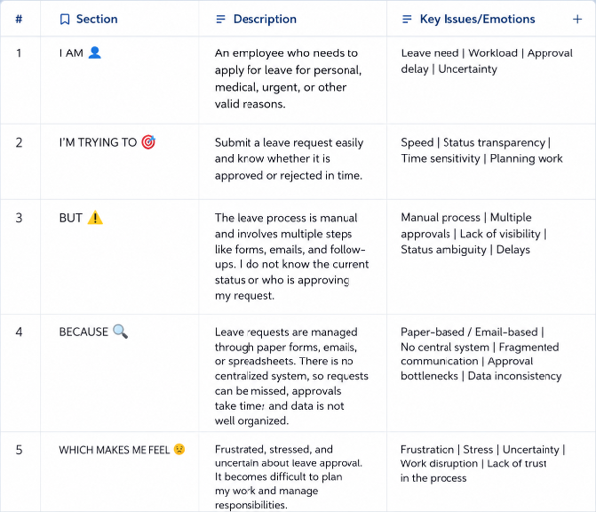

Problem Statement (PS) | I am (Customer) | I’m trying to | But | Because | Which makes me feel
PS-1 | Employee | Submit a leave request quickly and track its approval status. | The manual leave process is slow and difficult to monitor. | It requires paperwork or multiple email communications, and approvals may be delayed. | Frustrated, Uncertain, and Stressed.
PS-2 | Manager / Approver | Review and approve employee leave requests efficiently. | Managing multiple leave requests manually takes time and increases the chance of errors. | Leave requests come from different employees and need proper verification before approval. | Overloaded, Delayed, and Less Productive.

2.2 Empathy Map Canvas
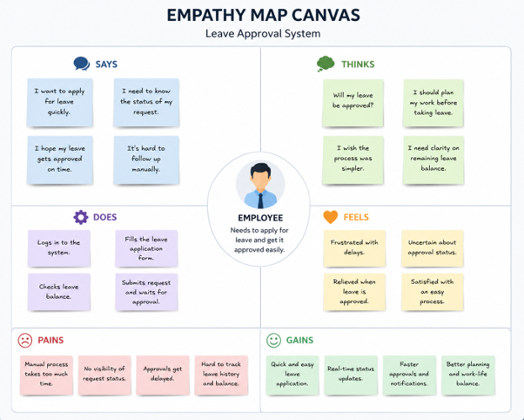

2.3 Brainstorming
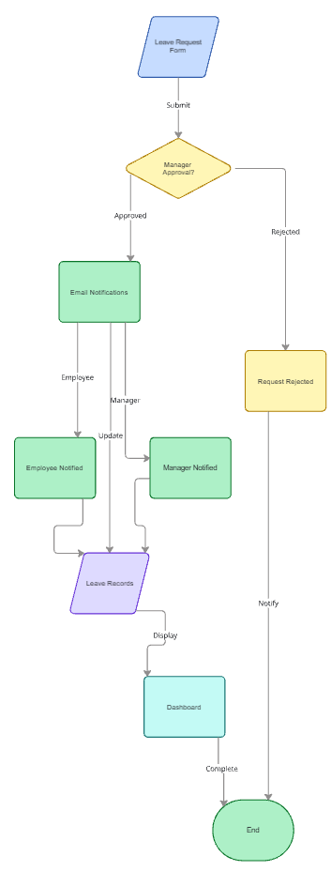

3. REQUIREMENT ANALYSYS
3.1 Customer Journey Map
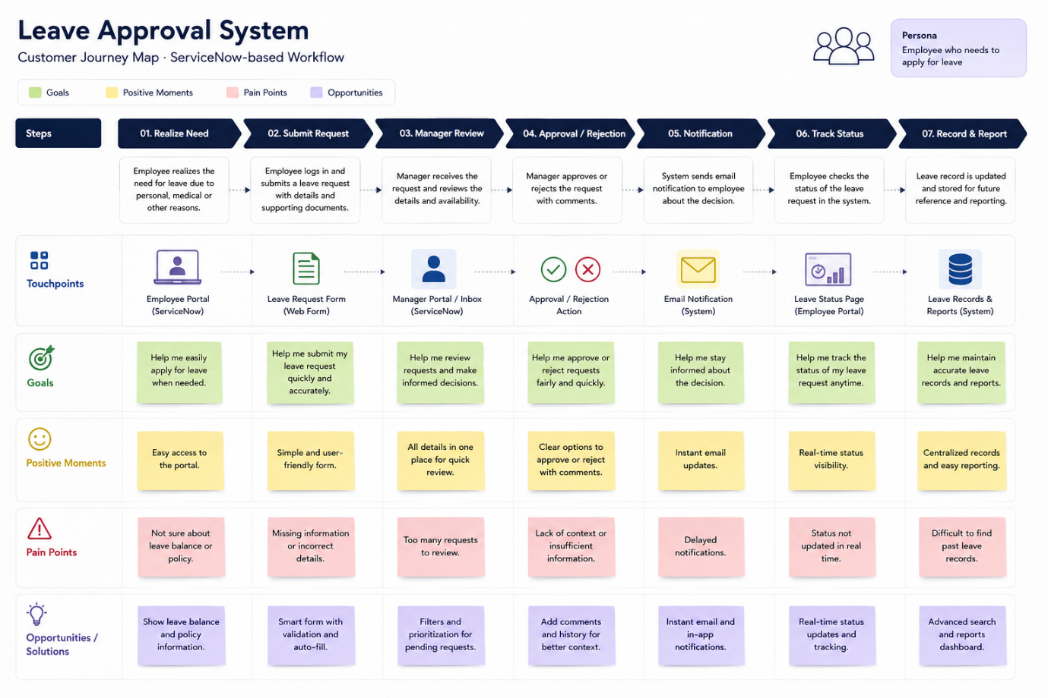

3.2 Solution Requirements
FR No. | Functional Requirement (Epic) | Sub Requirement (Story / Sub-Task)
FR-1 | User Authentication & Role Management | Authenticate users using the existing ServiceNow Users (sys_user) table.  Assign Employee role to employees.  Assign Manager role to approvers.  Assign Administrator role for system administration.
FR-2 | Leave Request Management | Employees can create and submit leave requests.  Employees can enter leave type, leave dates, reason, and attach supporting documents (if required).
FR-3 | Leave Request Review and Response | Managers can view pending leave requests.  Approve leave requests.  Reject leave requests with comments.  Update the leave request status.
FR-4 | Leave Status Tracking | Employees can view the status of submitted leave requests.  Status includes Pending, Approved, and Rejected.
FR-5 | Workflow Automation & Notifications | Trigger a ServiceNow Flow Designer workflow after leave submission and approval/rejection.  Send approval email notification.  Send rejection email notification.  Update leave records automatically.

Non-functional Requirements:
Following are the non-functional requirements of the proposed solution.
FR No. | Non-Functional Requirement | Description
NFR-1 | Usability | The application shall provide a simple, user-friendly interface for employees, managers, and administrators.
NFR-2 | Security | Access shall be controlled using ServiceNow roles. Employees can access only their own leave requests, while managers and administrators have access according to their assigned roles.
NFR-3 | Reliability | The application shall accurately store leave requests and process approvals without data loss.
NFR-4 | Performance | Leave requests, approvals, and email notifications shall be processed with minimal delay under normal usage.
NFR-5 | Availability | The Leave Approval System shall be available whenever the ServiceNow instance is operational.
NFR-6 | Scalability | The application shall support an increasing number of employees, managers, and leave requests without major design changes.

3.3 Data Flow Diagram: A Data Flow Diagram (DFD) is a traditional visual representation of the information flows within a system. A neat and clear DFD can depict the right amount of the system requirement graphically. It shows how data enters and leaves the system, what changes the information, and where data is stored.

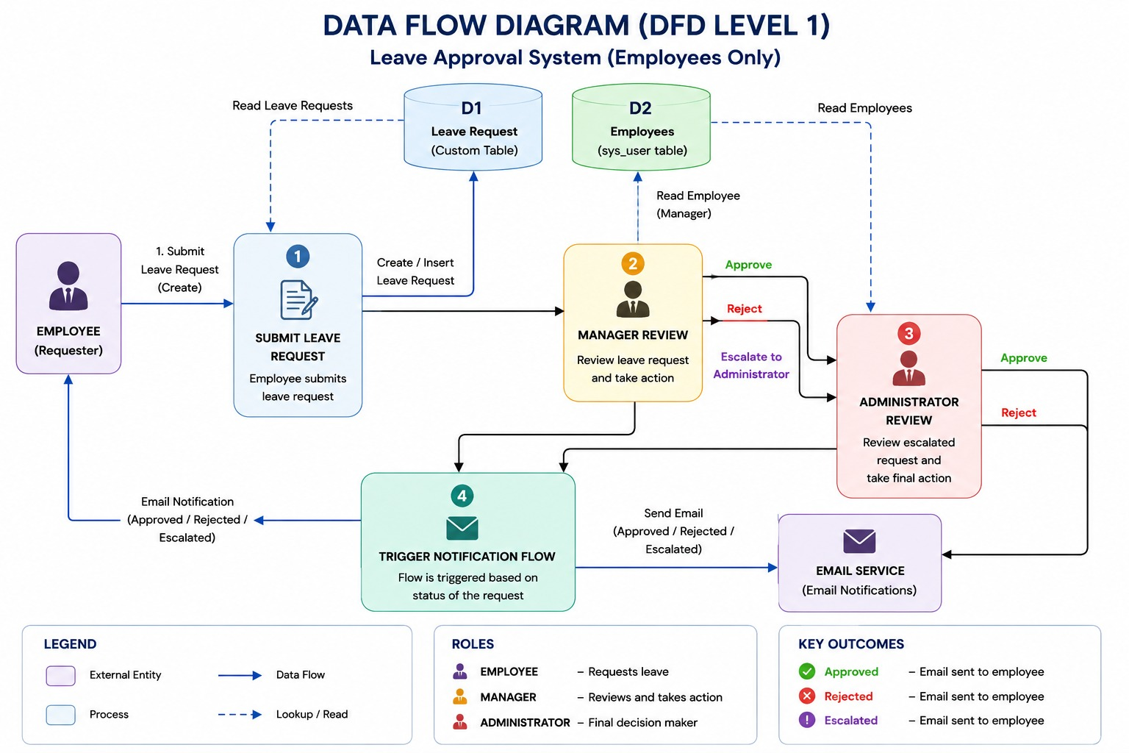

3.4 Technology Stack

Table 1: Components & Technologies
S.No | Component | Description | Technology
1 | User Interface | Employee, Manager, and Administrator views for leave management | ServiceNow Workspace / Forms / Lists
2 | Application Logic | Leave request creation, validation, approval, and status management | Business Rules, Client Scripts
3 | Workflow Automation | Leave approval workflow, notifications, and record updates | Flow Designer
4 | Database | Stores employee details and leave requests | sys_user, Custom Leave Request table
5 | Email Service | Sends approval and rejection email notifications | ServiceNow Notifications
6 | Security | Role-based access for employees, managers, and administrators | ACLs, Employee Role, Manager Role, Admin Role
7 | Infrastructure | ACLs, Employee Role, Manager Role, Admin Role | ServiceNow Cloud Platform

Table 2: Application Characteristics
Characteristic | Description | Technology
Security | Role-based access ensures employees, managers, and administrators access only authorized data. | ACLs, ServiceNow Roles
Scalability | Supports a growing number of employees and leave requests without major changes. | ServiceNow Platform
Availability | The application is available whenever the ServiceNow instance is operational. | ServiceNow Cloud
Performance | Leave requests, approvals, and notifications are processed efficiently. | Flow Designer, Business Rules
Reliability | Leave records and approval history are stored securely with accurate processing. | ServiceNow Database
Maintainability | Forms, workflows, business rules, and notifications can be updated easily without affecting existing data. | ServiceNow Studio, Flow Designer

4. PROJECT DESIGN
4.1 Problem Solution Fit
Section | Content
1. Customer Segment(s) | • Employees • Managers/Approvers • System Administrators
2. Jobs-to-be-done / Problems | • Submit leave requests online • Get quick approval or rejection • Track leave request status • Reduce paperwork • Maintain centralized leave records
3. Triggers | • Employee needs leave for personal, medical, vacation, or emergency reasons • Manager receives a new leave request • Administrator manages employee records and workflows
4. Emotions (Before / After) | Before: Frustrated, uncertain, stressed about approval delays. After: Confident, informed, satisfied, and stress-free.
5. Available Solutions | • Paper leave forms • Email requests • Phone calls • Manual approval process • Spreadsheet-based leave tracking
6. Customer Constraints | • Manual approval delays • No centralized leave tracking • Employees unaware of request status • Difficult to maintain leave records • Communication through multiple channels
7. Behaviour | • Employees submit leave requests via paper or email • Follow up repeatedly with managers • Managers manually review requests • Employees wait for approval updates
8. Channels of Behaviour | Online: ServiceNow application, Email notifications. Offline: Direct communication with managers or HR.
9. Problem Root Cause | The organization lacks a centralized digital leave management system. Manual leave processing causes delays, poor visibility, inconsistent tracking, and increased administrative effort.
10. Your Solution | Develop a ServiceNow Leave Approval System where employees submit leave requests online. Managers review and approve or reject requests. The system automatically updates the leave status, sends email notifications using ServiceNow Notifications, securely stores all leave records, and allows employees to track the status of their requests through the application.

4.2 Proposed Solution

S.No | Parameter | Description
1 | Problem Statement (Problem to be solved) | Many organizations manage employee leave requests manually through paper forms, emails, or verbal communication. This results in delayed approvals, lack of transparency, difficulty in tracking leave status, and inefficient communication between employees and managers.
2 | Idea / Solution Description | Develop a ServiceNow-based Leave Approval System where employees submit leave requests digitally. Managers review and approve or reject the requests through the application. ServiceNow Flow Designer automatically updates the request status and sends email notifications to employees. Employees can also track the status of their leave requests through the application.
3 | Novelty / Uniqueness | The solution integrates role-based access control, automated leave approval workflows, email notifications, centralized leave record management, and separate Employee, Manager, and Administrator views within a single ServiceNow application. It eliminates manual paperwork and improves the efficiency of the leave approval process.
4 | Social Impact / Customer Satisfaction | The application improves transparency, reduces paperwork, speeds up leave approvals, and enhances communication between employees and managers. Employees receive timely updates, while managers can efficiently manage leave requests through a centralized platform.
5 | Business Model (Revenue Model) | The solution is designed for organizations as an internal leave management application. It can be deployed across companies using the ServiceNow platform. Future enhancements can support a Software-as-a-Service (SaaS) model for multiple organizations.
6 | Scalability of the Solution | The application is built on the ServiceNow platform and can scale to support multiple departments, branches, and thousands of employees. Additional modules such as leave balance management, HR integration, reporting dashboards, mobile access, and analytics can be added without significant architectural changes.

4.3 Solution Architecture

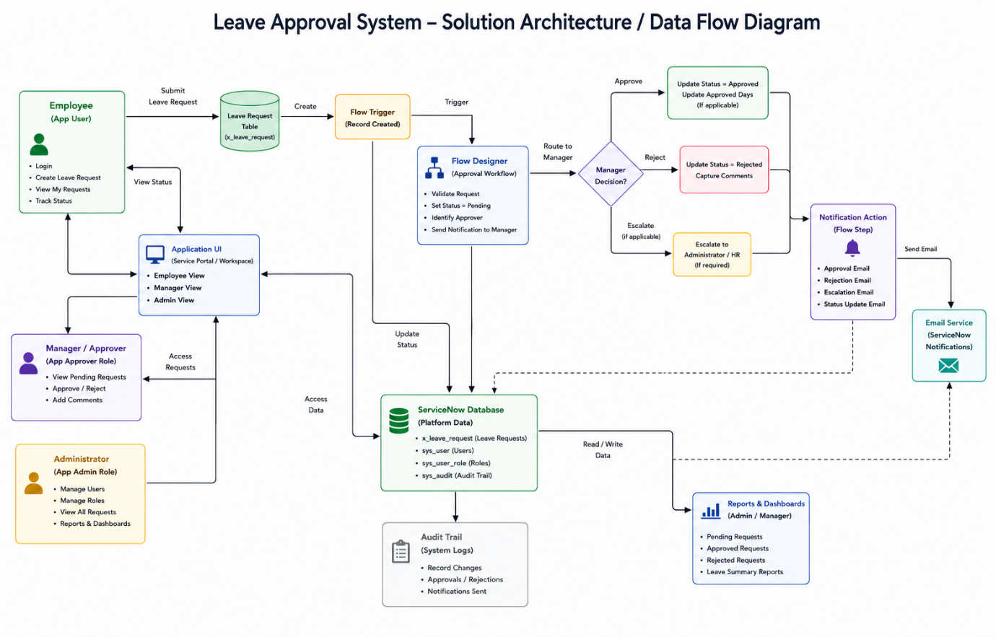

5. PROJECT PLANNING & SCHEDULING
Product Backlog, Sprint Schedule, and Estimation

Project Tracker, Velocity & Burndown Chart: (4 Marks)
Sprint | Total Story Points | Duration | Sprint Start Date | Sprint End Date (Planned) | Story Points Completed (as on Planned End Date) | Sprint Release Date (Actual)
Sprint-1 | 8 | 2 Days | 22 June 2026 | 23 June 2026 | 8 | 23 June 2026
Sprint-2 | 9 | 2 Days | 24 June 2026 | 25 June 2026 | 9 | 25 June 2026
Sprint-3 | 8 | 2 Days | 26 June 2026 | 27 June 2026 | 8 | 27 June 2026
Sprint-4 | 5 | 1 Day | 28 June 2026 | 28 June 2026 | 5 | 28 June 2026

Velocity:

- Total Story Points: 30
- Total Duration: 7 days
Average Velocity = 30 ÷ 7 ≈ 4.3 story points/day

6. FUNCTIONAL AND PERFORMANCE TESTING
2. Milestone 1 – Application Setup
Objective
Create the scoped application and initialize the project.
Activities Performed
- Created a new scoped application.
- Configured the application menu and modules.
- Prepared the development environment.
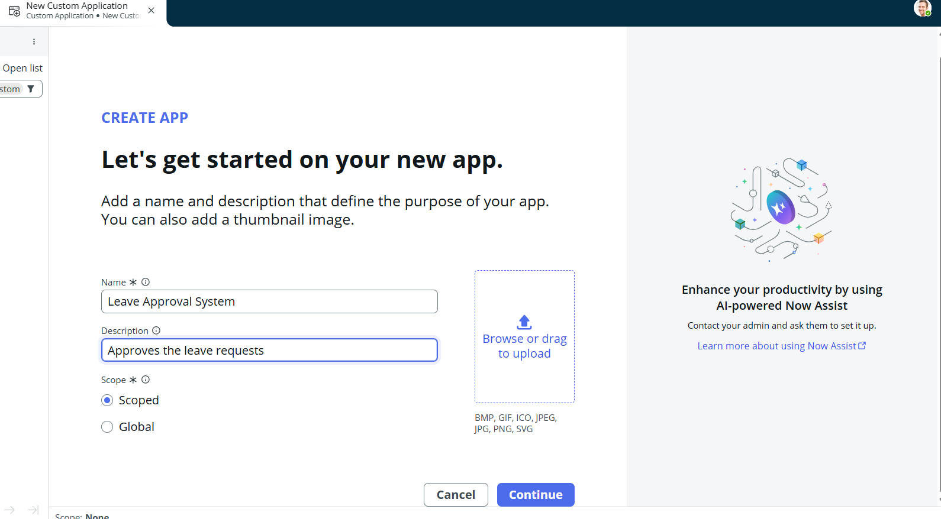

3. Milestone 2 – Database Configuration
Objective
Create the Leave Request table for storing leave applications.
Activities Performed
- Designed the Leave Request table.
- Added fields such as Employee, Leave Type, Start Date, End Date, Reason, Status, Manager Comments, and Approval Date.
- Configured reference fields to the ServiceNow Users table (sys_user).
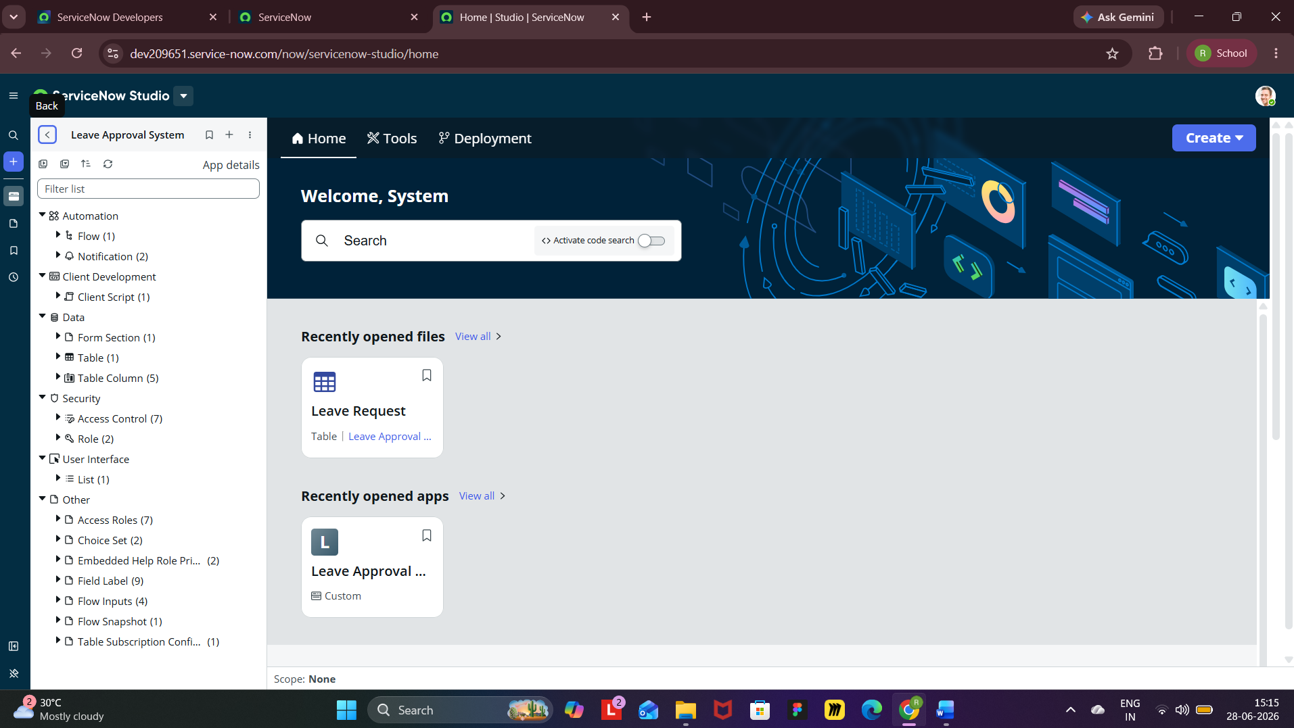
4. Milestone 3 – User & Role Configuration
Configure users and application roles.
Activities Performed
- Created Employee user accounts.
- Created Manager user account.
- Assigned Employee role to employees.
- Assigned Manager and Administrator roles to authorized users.
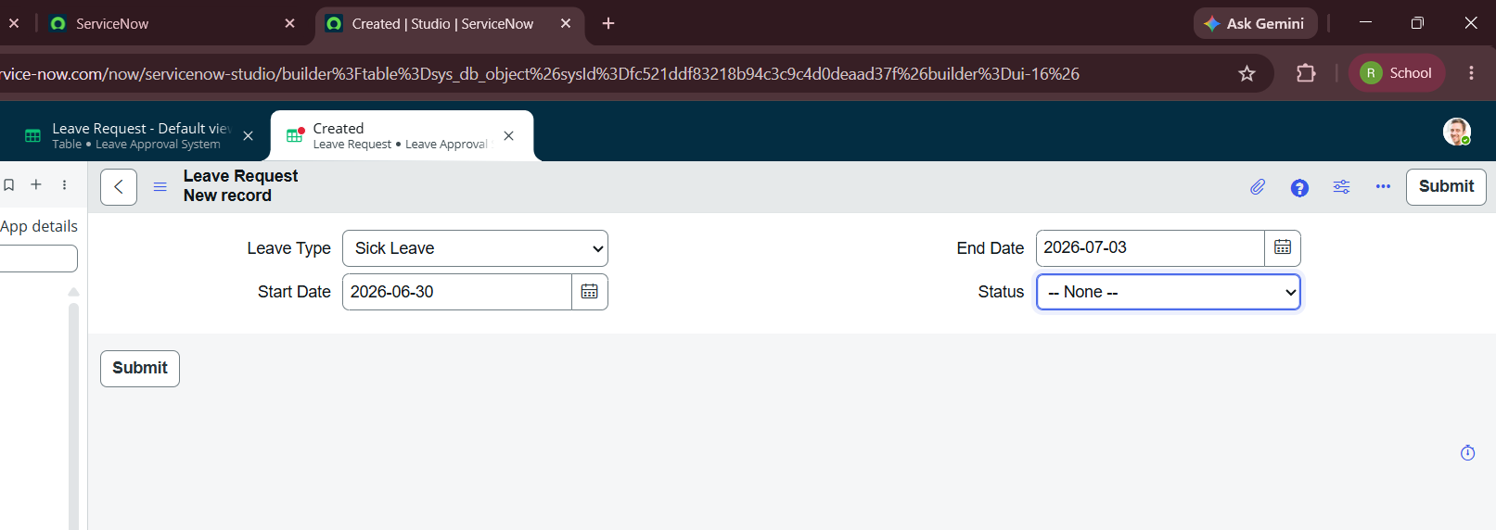
5. Milestone 4 – User Interface Development
Objective
Develop user-friendly interfaces for students and faculty.
Activities Performed
- Designed the Employee Leave Request form.
- Configured separate Employee and Manager view.
- Implemented UI Policies for dynamic form behavior.

6. Milestone 5 – Workflow Automation
Objective
Automate leave approval and notification process.
Activities Performed
- Developed a Flow Designer workflow.
- Triggered the workflow whenever the leave status changes.
- Configured email notifications for Approved and Rejected leave requests.
- Automatically updated leave request status.

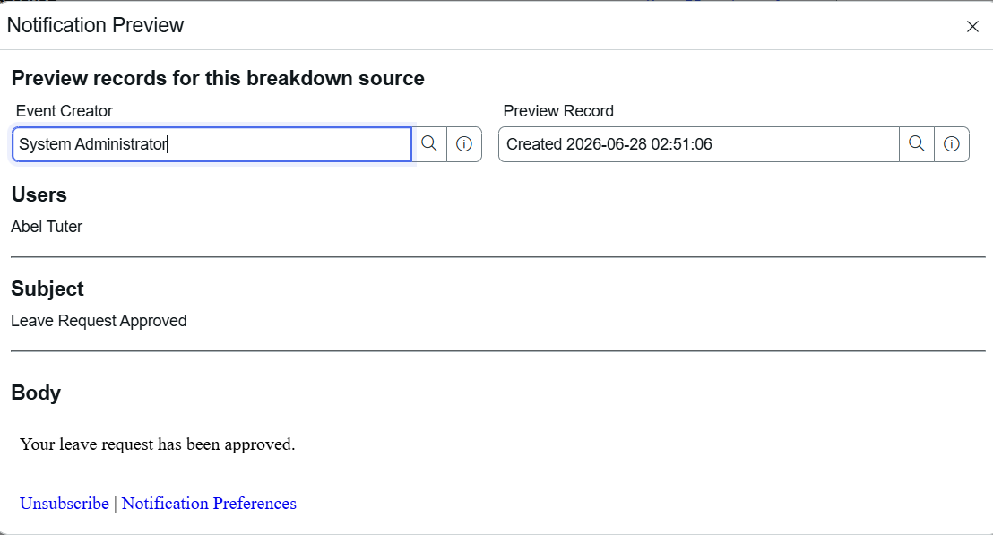


7. Milestone 6 – Application Testing
Objective
Validate the end-to-end functionality of the application.
Test Scenario 1
Employee submits a leave request.
Expected Result:
Leave request is created successfully.
Status:
Passed
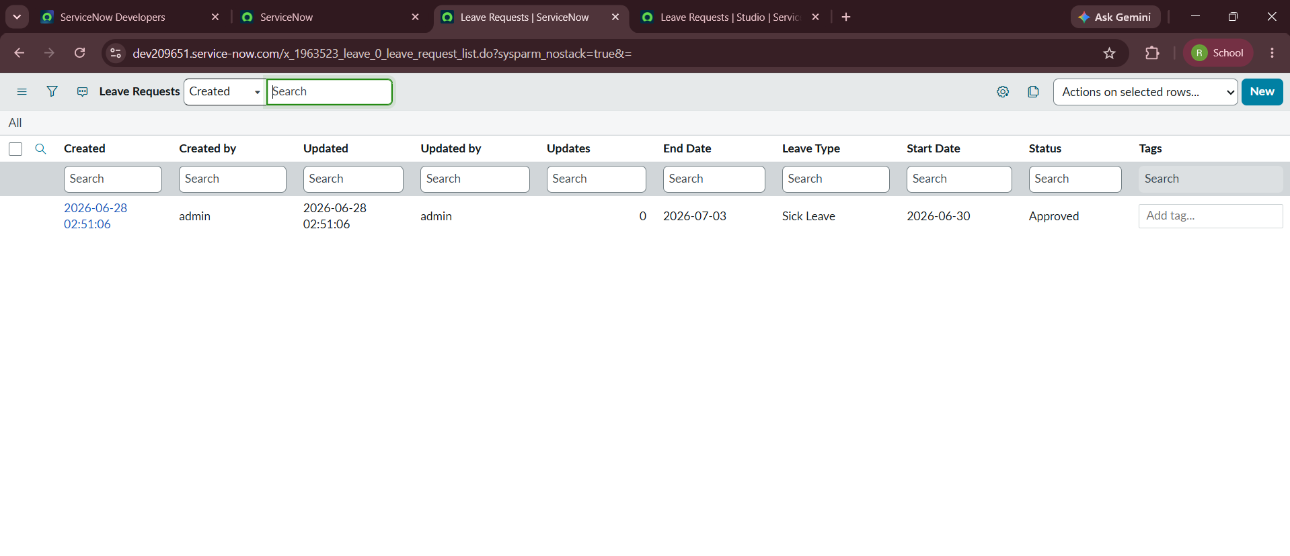

Test Scenario 2
Manager approves a leave request.
Expected Result:
Status changes to Approved and an email notification is sent to the employee.
Status:
Passed

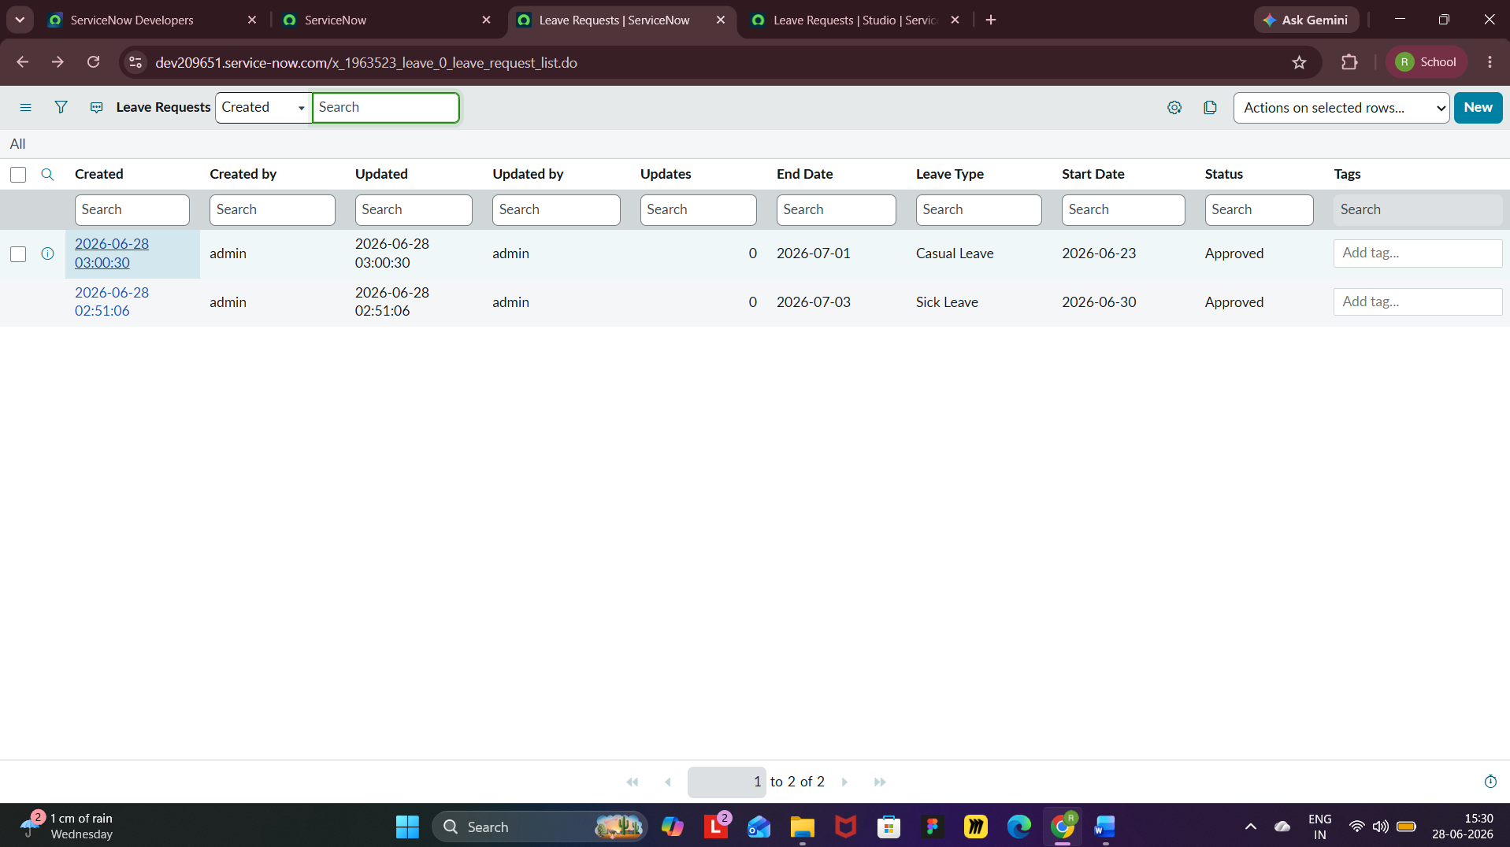

Test Scenario 3
Manager rejects a leave request.
Expected Result:
Status changes to Rejected and an email notification is sent to the employee.
Status:
Passed

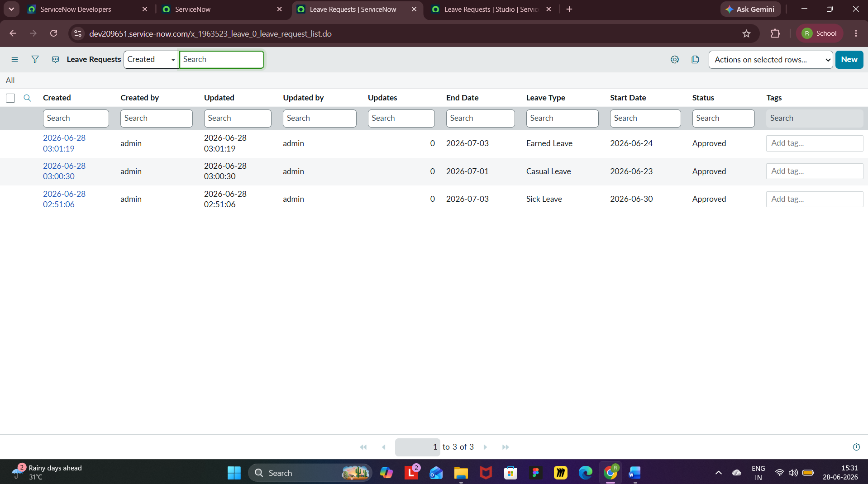

Test Scenario 4
Role-based access testing.
Expected Result:
Employees can access only their own leave requests, while managers can view and manage assigned requests.
Status:
Passed
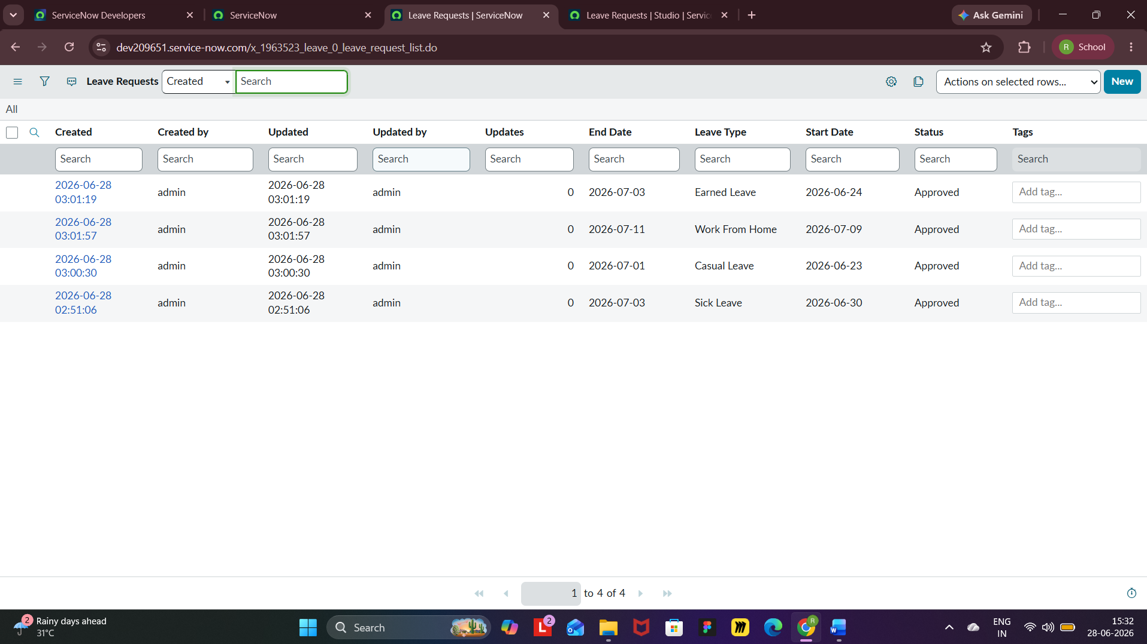

8 Development Summary
The Leave Approval System successfully implements a centralized leave management workflow using the ServiceNow platform. The application provides secure role-based access, employee leave request submission, manager approval and rejection, workflow automation using Flow Designer, email notifications, and centralized leave record management. All functional requirements were successfully implemented and validated through testing.

7. RESULTS
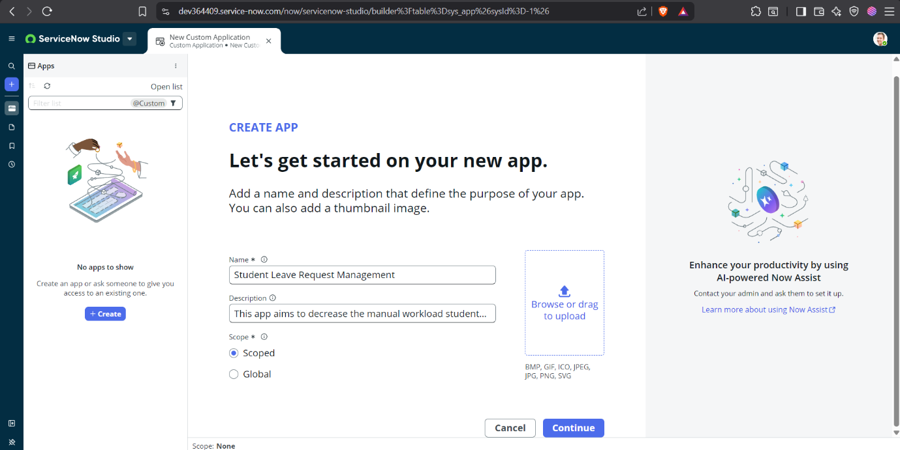

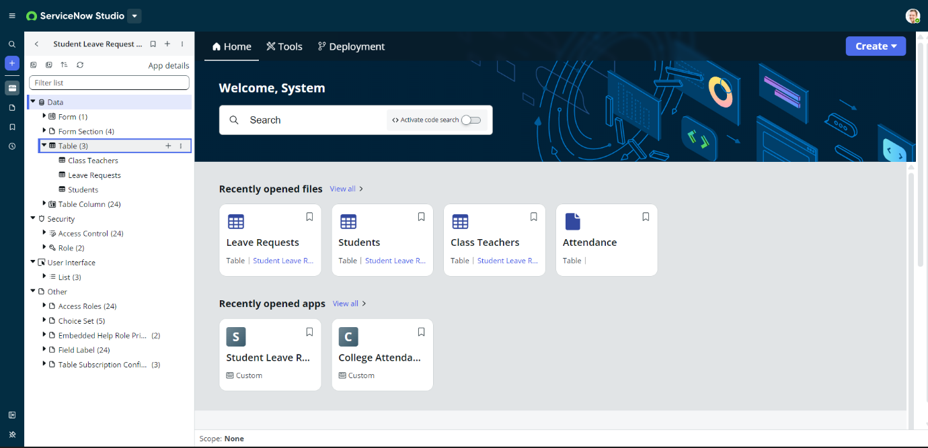

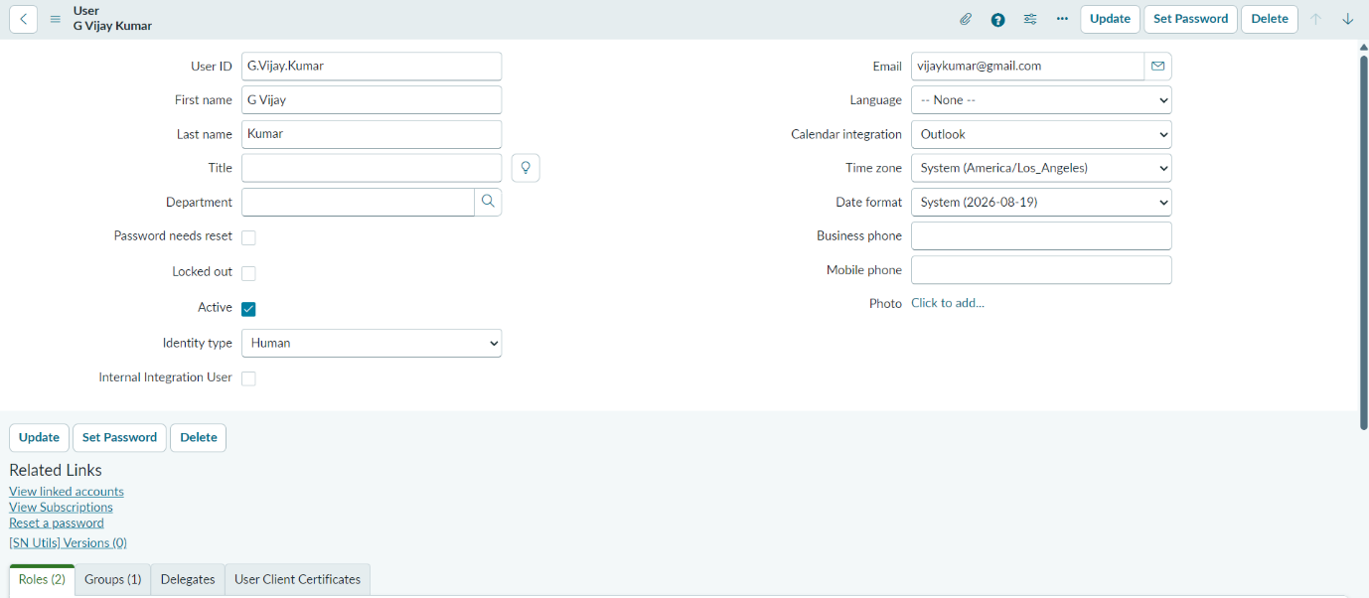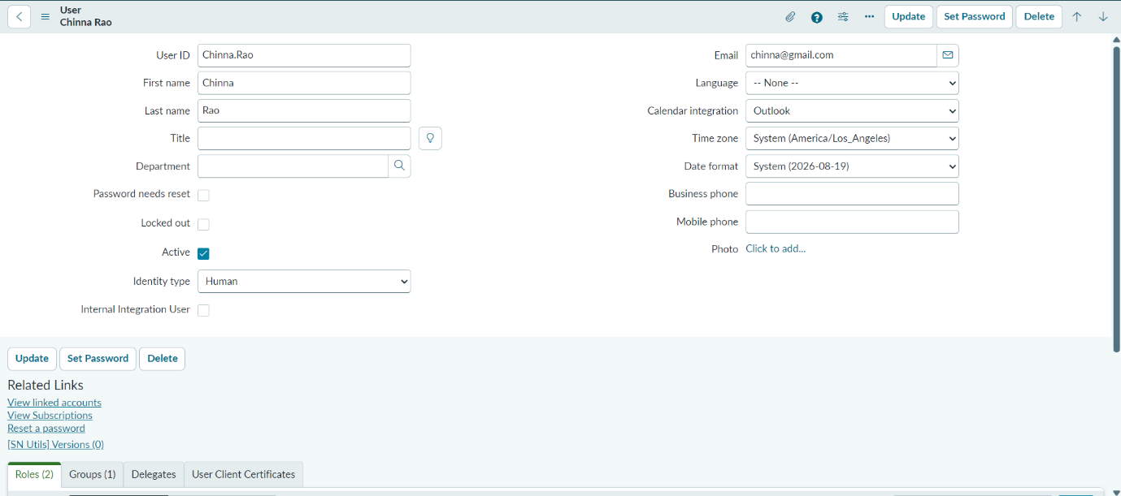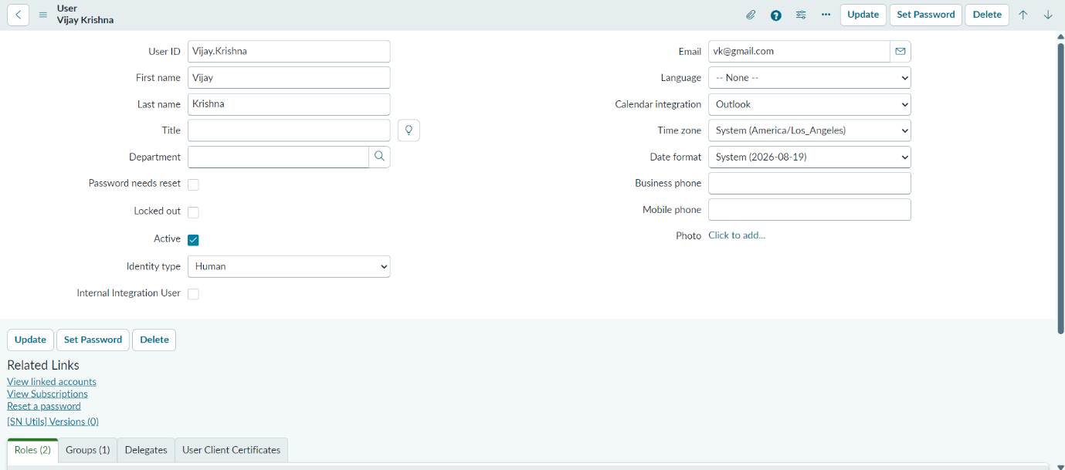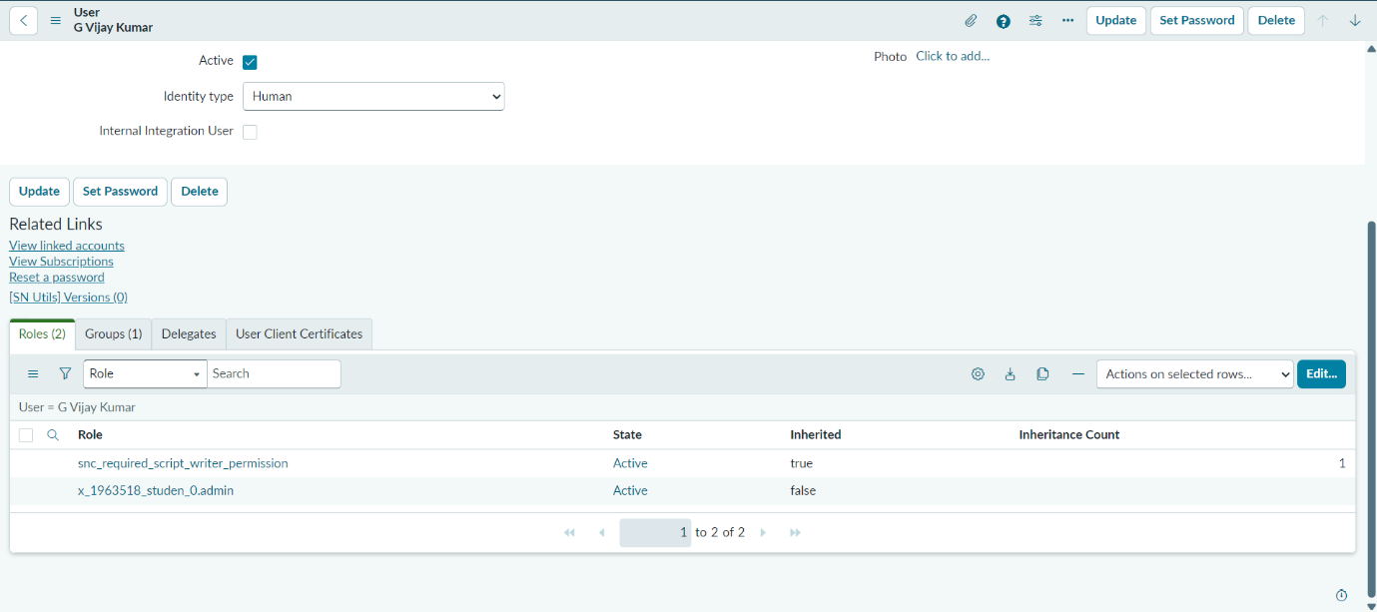

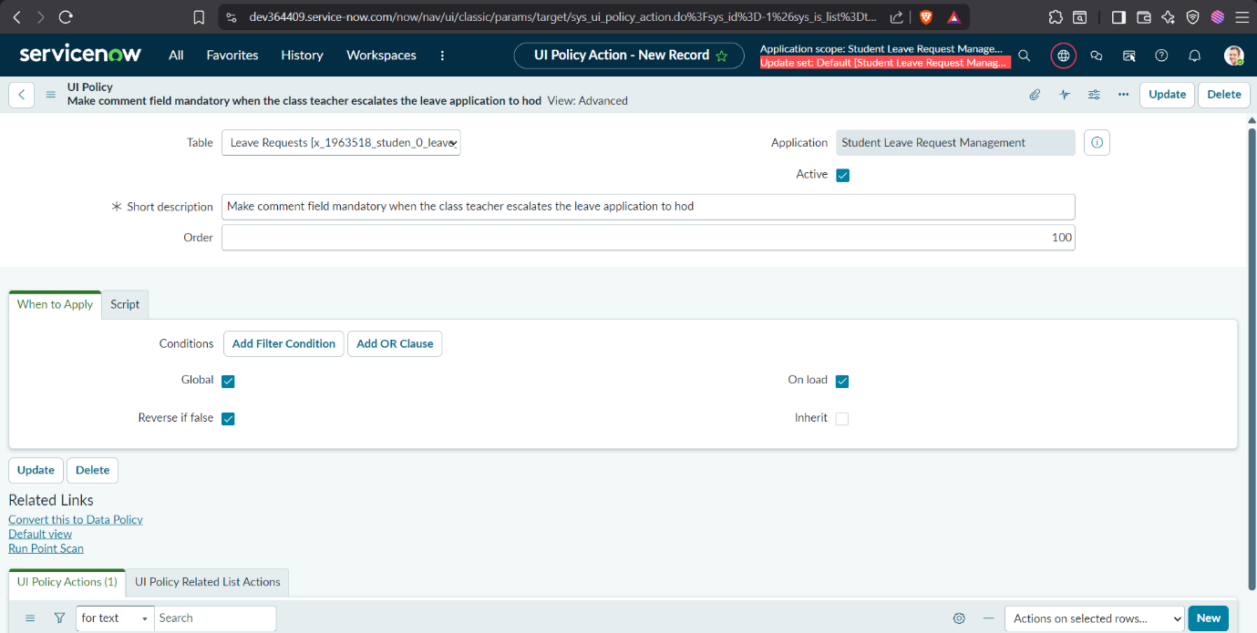

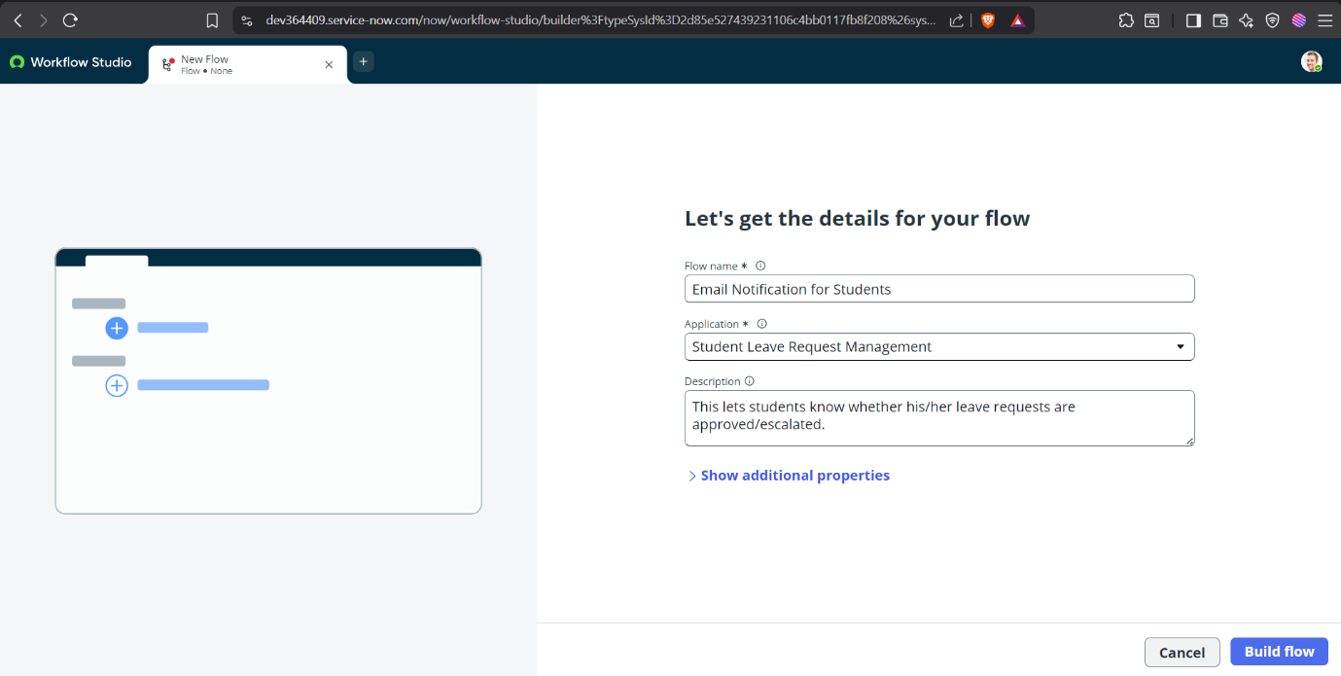

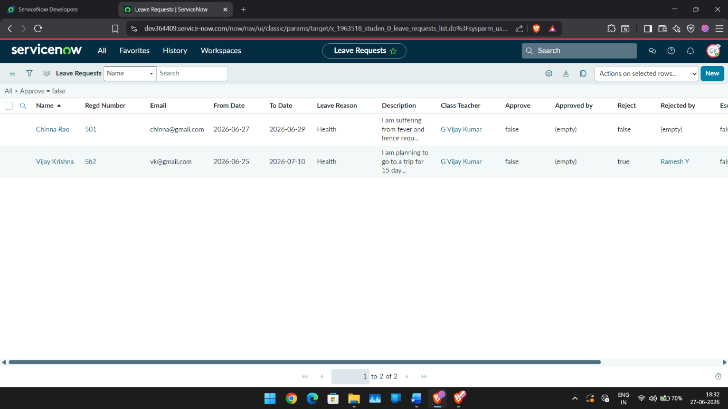

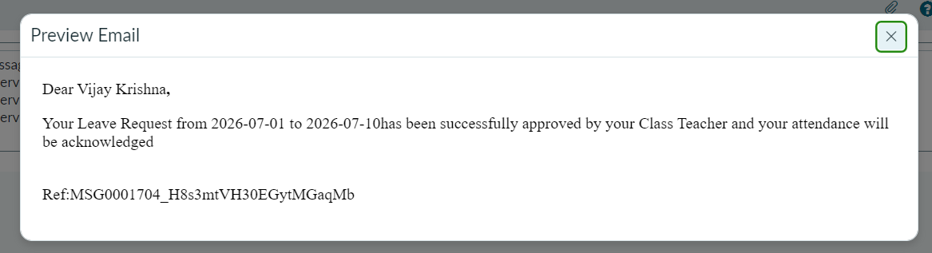

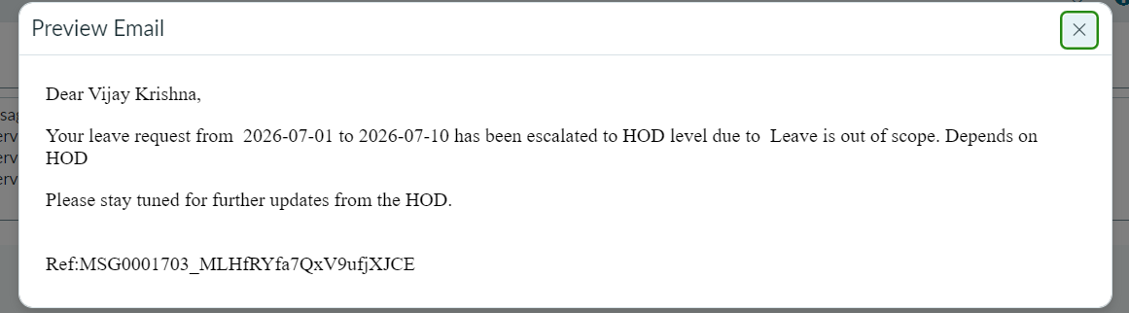

8. ADVANTAGES AND DISADVANTAGES
Advantages
- Paperless Leave Management
Eliminates paper forms and manual documentation by digitizing the entire leave request process.
- Centralized Leave Tracking
All leave requests are stored in a single system, making it easy for students and faculty to access and manage records.
- Role-Based Access Control
Students can access only their own leave requests, while faculty members can review and manage requests assigned to them.
- Improved Transparency
Students can view the status of their leave requests, reducing uncertainty and the need for repeated follow-ups.
- Automated Email Notifications
The system automatically sends email notifications when a leave request is approved, rejected, or escalated.
- Efficient Approval Workflow
Class Teachers can process leave requests directly and manually escalate requests exceeding five days to the HOD when necessary.
- Reduced Administrative Workload
Faculty members can manage leave requests through a centralized interface instead of handling requests via multiple communication channels.
- Secure User Management
User authentication is handled through the existing ServiceNow Users (sys_user) table with application-specific roles.
- Scalable Architecture
The application can be extended to support multiple departments, additional approval levels, or integration with other campus systems.
- Easy Maintenance
Since the application is built on the ServiceNow platform using configurable components such as Flow Designer and Business Rules, future modifications can be implemented with minimal effort.
Disadvantages
- Requires ServiceNow Platform
The application depends on a ServiceNow instance and cannot operate independently without the platform.
- Internet Dependency
Users must have an active internet connection to submit, review, or approve leave requests.
- Manual Escalation Required
Leave requests exceeding five days require the Class Teacher to manually forward them to the HOD, which relies on timely faculty action.
- Limited to Institutional Workflow
The application is designed specifically for student leave management and requires customization for use in other domains.
- Initial User Configuration
Student and faculty accounts, roles, and reference fields must be configured before the system can be used effectively.
- Email Delivery Dependency
Notifications depend on proper email configuration within the ServiceNow instance.
- No Attendance Integration
The current implementation does not automatically synchronize approved leave with the institution's attendance management system.
- Limited Reporting Features
Basic reporting is supported, but advanced analytics and dashboards require further development.

9. CONCLUSION
The Student Leave Automation System successfully demonstrates how the ServiceNow platform can be utilized to digitize and streamline the student leave approval process within educational institutions. The application replaces traditional manual methods with a centralized, role-based system that enables students to submit leave requests online while allowing Class Teachers and Heads of Department (HODs) to efficiently review, approve, reject, or manually escalate requests based on institutional policies. Through the implementation of ServiceNow features such as scoped applications, custom tables, Business Rules, Flow Designer, UI Policies, roles, and email notifications, the system provides a structured and transparent workflow that improves communication and reduces administrative effort.
The project successfully achieved its primary objectives by providing a secure, user-friendly, and scalable leave management solution. Functional testing verified that all major features—including leave submission, approval workflow, manual escalation, status tracking, and automated email notifications—performed as expected. Overall, the proposed solution enhances operational efficiency, improves the user experience for both students and faculty, and serves as a strong foundation for future enhancements such as attendance integration, mobile access, analytics dashboards, and advanced reporting capabilities.

10. FUTURE SCOPE
The Student Leave Automation System provides a strong foundation for digital leave management and can be further enhanced with additional features to improve functionality and user experience. Future enhancements may include integration with the institution's attendance management system to automatically update attendance records after leave approval, eliminating manual intervention. The application can also be extended with a dedicated mobile interface, enabling students and faculty to submit and review leave requests from smartphones.
Additional improvements include implementing analytics dashboards to monitor leave trends, department-wise statistics, and approval turnaround times. The system can be integrated with academic calendars to validate leave requests against examination schedules and institutional holidays. Multi-level approval workflows can be introduced for larger institutions requiring approvals from additional authorities. Furthermore, SMS or mobile push notifications can complement email notifications for faster communication. These enhancements would make the application more comprehensive, scalable, and suitable for deployment across multiple educational institutions while continuing to improve administrative efficiency and the overall user experience.

APPENDIX
INTRODUCTION 01
IDEATION PHASE 02
REQUIREMENT ANALYSIS 05
PROJECT DESIGN 09
PLANNING AND SCHEDULING 12
FUNCTIONAL AND PERFORMANCE TESTING 13
RESULTS 21
ADVANTAGES AND DISADVANTAGES 26
CONCLUSION 28
FUTURE SCOPE 28

